Graph, DP. Normal
In Milky Way galaxy there is a planet Neptune with N cities. Some of them are connected with roads.
Adjacency matrix - matrix N*N, for each pair you have 1 or 0: if i-th city is connected with k-th city by road-1, otherwise-0.
Adjacency list - you have a list with pairs of connected roads
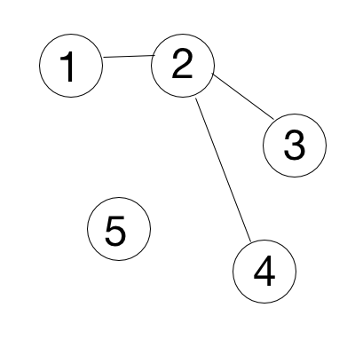
- [Graph] Roads Count. You need to print out a count of roads by given adjacency matrix. Input: 1st row - N, number of cities, next N rows - adjacency matrix.
Input: Output:
5 3
0 1 0 0 0
1 0 1 1 0
0 1 0 0 0
0 1 0 0 0
0 0 0 0 0
- [Graph] Find a ring road. You need to print “Ring road” if there are roads that make a ring road, “Tree structure” - otherwise. Input: 1st row - N, number of cities, next N rows - adjacency matrix.
Input: Output: Input: Output:
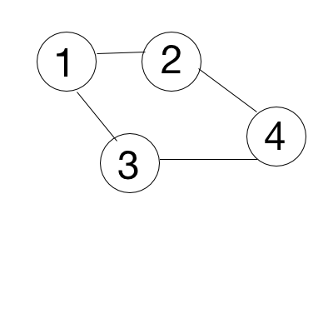
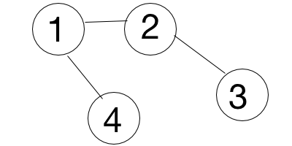
4 Ring road 4 Tree structure
1 1 1 0 1 1 0 1
1 1 0 1 1 1 1 0
1 0 1 1 0 0 1 0
0 1 1 1 1 0 0 1
- [Graph] Is there another country? If two cities are connected, they belong to the same country. You need to check if there is only one country on a planet. Print YES - if only one, NO - otherwise. Input: 1st row - N, K, where N - number of cities, K - number of roads, next K rows - adjacency list.
Input: Output: Input: Output: Input: Output:
5 4 YES 1 0 YES 5 2 NO
1 2 1 2
3 4 4 5
5 2
4 5
Dynamic programming is a technique for solving problems with the following properties:
- An instance is solved using the solutions for smaller instances.
- The solution for a smaller instance might be needed multiple times.
- The solutions to smaller instances are stored in a table, so that each smaller instance is solved only once.
- Additional space is used to save time.

- [DP] The Fibonacci numbers. Write a function that returns $F_{n}$.
In mathematical terms, the sequence Fn of Fibonacci numbers is defined by the recurrence relation with seed values $F_{n}= F_{n-1}+F_{n-2}$ with $F_{0}= 0$ and $F_{1}= 1.$
0, 1, 1, 2, 3, 5, 8, 13, 21, 34, 55, 89, 141, ……..
Input: 3 Output: 2 Input: 10 Output: 55
- [DP] Making change. Given an infinite number of quarters (25 cents), dimes (10 cents), nickels (5 cents) and pennies (1 cent). Write a code to calculate the number of ways of representing n cents.
Input: 3 Output: 1 (1+1+1) Input: 10 Output: 4 (10, 5+5, 5+1+1+1+1+1, 1+1+..+1+1)
- [DP] Maximum Subarray. Find the contiguous subarray within an array (containing at least one number) which has the largest sum.
Input: [−2,1,−3,4,−1,2,1,−5,4] Output: 6 ([4,−1,2,1])

Graph, DP. Advanced
In Milky Way galaxy there is a planet Neptune with N cities. Some of them are connected with roads.
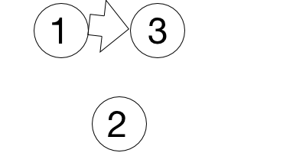
- [Graph] Find a ring road. Some of those roads are one way roads. You need to print “Ring road” if there are roads that make a ring road, “Tree structure” - otherwise. Input: 1st row - N, number of cities, next N rows - adjacency matrix.
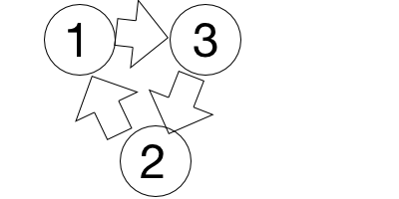
Input: Output: Input: Output:
3 Ring road 3 Tree structure
1 0 1 1 0 1
1 1 0 0 1 0
0 1 1 0 0 1
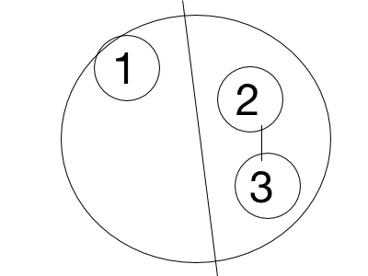
- [Graph] Path from near side to far side. Some of those cities are on the near side of Neptune, others are on the far side. Print ”YES” if there is a path from the near side to the far side. Input: 1st row - N, M, K, where N - total number of cities, M - number of cities on the rear side, K - number of roads, 2nd row - K cities from the rear side, next K rows - adjacency list.
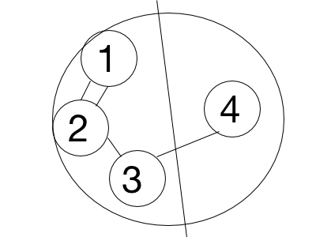
Input: Output: Input: Output:
5 4 3 <- 5 vertices, 4 roads. 3 vertices on a near side YES 3 1 1 NO
1 2 3 <- 3 vertices on a near side 1
1 2 2 3
2 1
2 3
3 4
- [Graph] Is there another country? If two cities are connected, they belong to the same country. You need to print all cities for each country. Input: 1st row - N, K, where N - number of cities, K - number of roads, next K rows - adjacency list.
Input: Output: Input: Output: Input: Output:
5 3 1 2 5 1 0 1 5 2 1 2
1 2 3 4 1 2 3
3 4 4 5 4 5
5 2
Dynamic programming is a technique for solving problems with the following properties:
- An instance is solved using the solutions for smaller instances.
- The solution for a smaller instance might be needed multiple times.
- The solutions to smaller instances are stored in a table, so that each smaller instance is solved only once.
- Additional space is used to save time.
- [DP] Fibonacci Modified. A series is defined in the following manner:Given the nth and (n+1)th terms, the (n+2)th can be computed by the following relation T_{n+2} = (T_{n+1})² + T_{n}
So, if the first two terms of the series are 0 and 1: T₃ = 1^2 + 0 = 1 T₄ = 1^2 + 1 = 2 T₅ = 2^2 + 1 = 5.
Given three integers A, B and N, such that the first two terms of the series (1st and 2nd terms) are A and B respectively, compute the Nth term of the series.
Input: 0 1 5 Output: 5
- [DP] Minimum Number of Coins. Given a list of N coins, their values (V₁, V₂, ... , V_{N}), and the total sum S. Find the minimum number of coins the sum of which is S (we can use as many coins of one type as we want), or report that it's not possible to select coins in such a way that they sum up to S.
Input: Input:
5 10 5 3
1 1 1 1 2 1 2 3
Output: Output:
0 1
- [DP] Bricks Game. You and your friend decide to play a game using a stack consisting of N bricks. In this game, you can alternatively remove 1, 2 or 3 bricks from the top, and the numbers etched on the removed bricks are added to your score. You have to play so that you obtain the maximum possible score. It is given that your friend will also play optimally and you make the first move. Input: first line will contain a number N i.e. number of elements in the stack and next line will contain N numbers i.e. numbers etched on bricks from top to bottom.
5 5
999 1 1 1 0 0 1 1 1 999
Output: 1001 Output: 999

